

(23cse113) object oriented programming language

LAB document

# CSE-1st YEAR I SEMESTER (2024-2025)

SUBMITTED TO: SUBMITTED FROM:

|  |  |  |  |
| --- | --- | --- | --- |
| **NAME** | A.Lalith sai akshith | **NAME** | Raj kumar |
| **ROLL NO** | **AV.SC.U4Cse24301** | **DEPARTMAENT** | OOPS |
| **SECTION** | **CSE-A** | **DESIGNATION** | **PROFESSOR** |

INDEX

|  |  |
| --- | --- |
| **S.NO** | **TITLE** |
| 1. | Week 1 |
| 2. | Week2 |
| 3. | Week 3 |
| 4. | Week 4 |
| 5. |  |
| 6. |  |
| 7. |  |
| 8. |  |
| 9. |  |

Week1:

program 1

AIM: To download and install java.

Procedure:  
step1:GO to browser and search “download java ”.

Step2: when you search you can see oracle website to

download java , click on it.



Step3:Download the java JDK21 version in linux/macOS/windows in “64x installer”.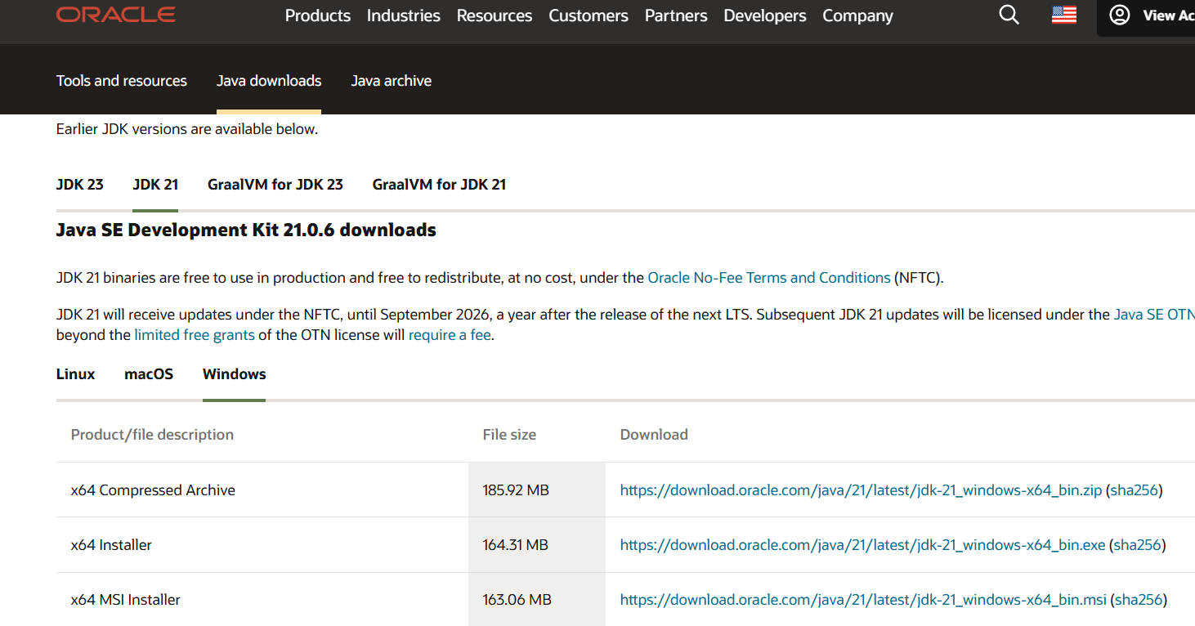

Step4: After downloading JDK 21 java version download the installer of java.



Step 5:After installing java Go to environment variable, click on path and add the java folder in it.

Step 6: Go to command prompt and type java –version.

You can see the version of java downloaded.

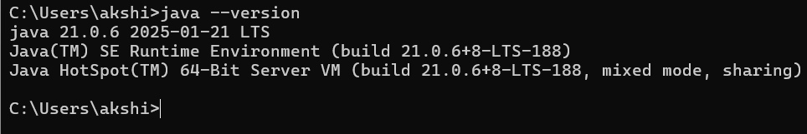

Program 2:java program to print the message welcome to java programming.

Aim:to create java program to print the message welcome to java programming.

PROCEDURE:

Step1: create a folder in and name it JAVA and create a notepad folder in JAVA folder and name it Helloworld.java.

Step 2: open the notepad folder and write the code of “welcome to java programming” . Ensure that the class and the file name is same.

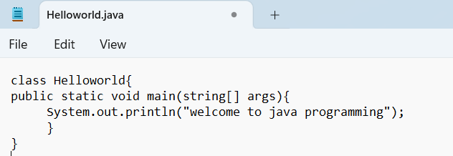

Step3: Save the notepad file and open the file in the command prompt window .

Step4:Compile the program by using command

Javac Helloworld.java and press enter.

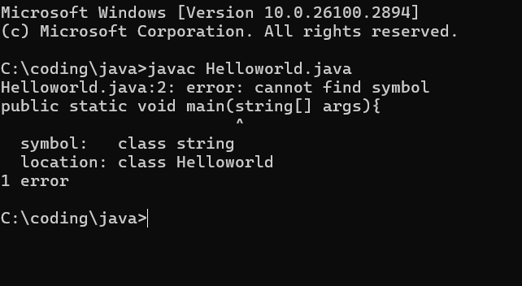

Step5: So we are getting an error which is in the class string. Go to notepad and correct the mistake in the class string.

Step6: Now save the java file and open the command window and type javac Helloworld.java and compile it.

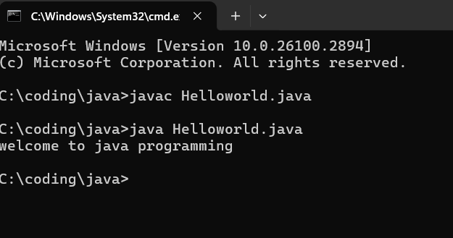

Now, the java program is correctly excecuted and there are no errors in the java program.

Program3: Write java program that prints name , roll number & section of a student.

Aim: To create java program that prints name , roll number & section of a student.

PROCEDURE:  
Step1: create new notepad folder and write the code of java program that prints name , roll number & section of a student.

Step2:Save the file as StudentInfo.java and open the notepad file in command prompt and compile javac studentInfo.java.

Step3: So we are getting 3 errors which is in the printing statement. Go to notepad and correct the mistake in the printing statement.

Step4: Now save the java file and open the command window and type javac StudentInfo.java and compile it.

Step5:Now, the java program is correctly excecuted and there are no errors in the java program.

Week 2:

Program3: Write java program that prints Area of rectangle

Aim: java program that prints Area of rectangle.

Step1: create new notepad folder and write the code of java program that prints the area of rectangle.

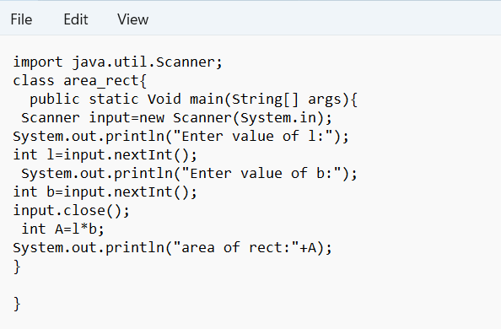

Step2:Save the file as area_rect.java and open the notepad file in command prompt and compile javac area_rect.java.

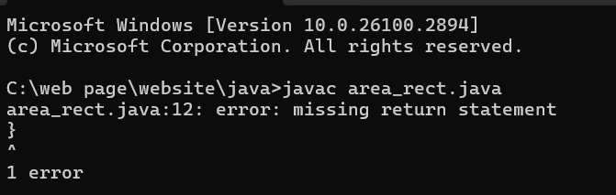

Step3: So we are getting error which is in the return statement. Go to notepad and correct the mistake in the printing statement.

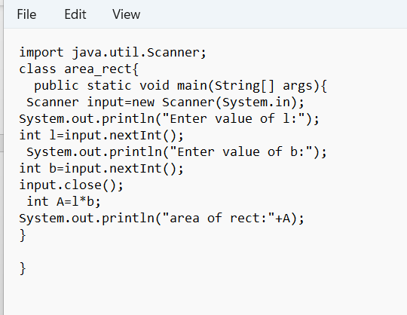

Step4: Now save the java file and open the command window and type javac area_rect.java and compile it.

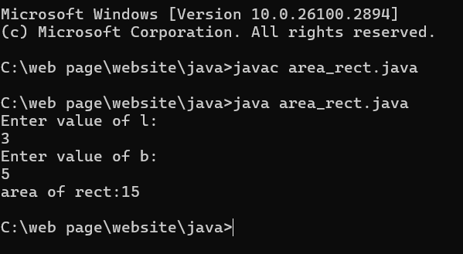

Step5:Now, the java program is correctly excecuted and there are no errors in the java program.

Program4: Write java program that prints factorial of number

Aim: java program that prints factorial of number.

Step1: create new notepad folder and write the code of java program that prints the factorial of number.

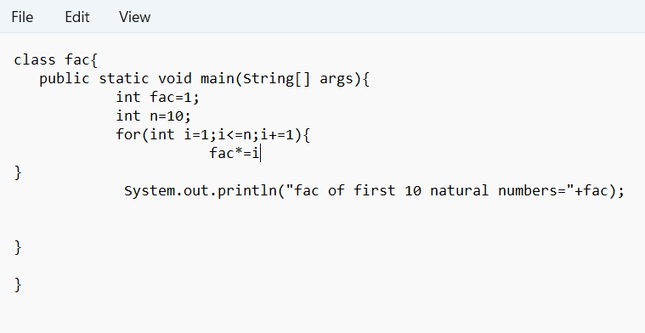

Step2:Save the file as fac.java and open the notepad file in command prompt and compile it.

Step3: So we are getting error which is in the fac*=i statement. Go to notepad and correct the mistake in the statement.

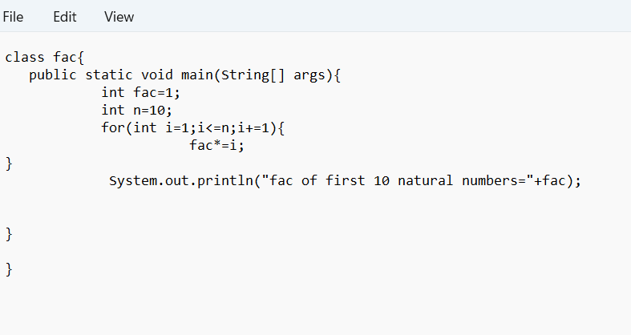

Step4: Add the semicoloum after error and Now save the java file and open the command window and type javac fac.java and compile it.

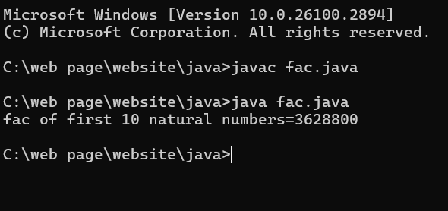

Step5:Now, the java program is correctly excecuted and there are no errors in the java program.

Program4: Write java program that prints largest of 3 numbers.

Aim: java program that prints largest of 3 numbers.

Step1: create new notepad folder and write the code of java program that prints the factorial of number.

Step2:Save the file as fac.java and open the notepad file in command prompt and compile it.

Step3: So we are getting 4errors which is in the c variable . Go to notepad and correct the mistake in the statement.

ERROR:

Add int c=input.nextInt();in the c input

Step4: Now save the java file and open the command window and type javac largest.java and compile it.Step5:Now, the java program is correctly excecuted and there are no errors in the java program.

Program5: Write java program that prints fibinocci of number.

Aim: java program that prints fibinocci.

Step1: create new notepad folder and write the code of java program that prints the fibinocci. 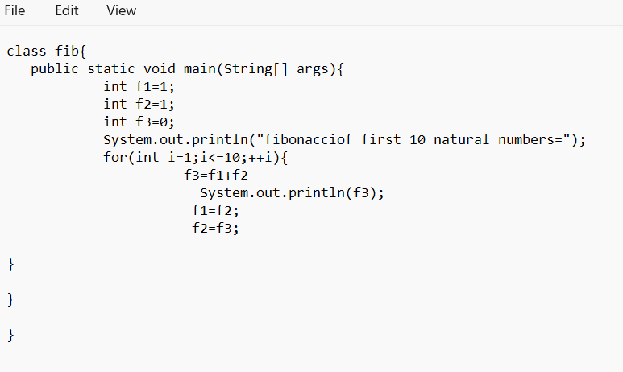

Step2:Save the file as fib.java and open the notepad file in command prompt and compile it.

Step3: So we are getting 1errors which is in the f3 variable . Go to notepad and correct the mistake in the statement.

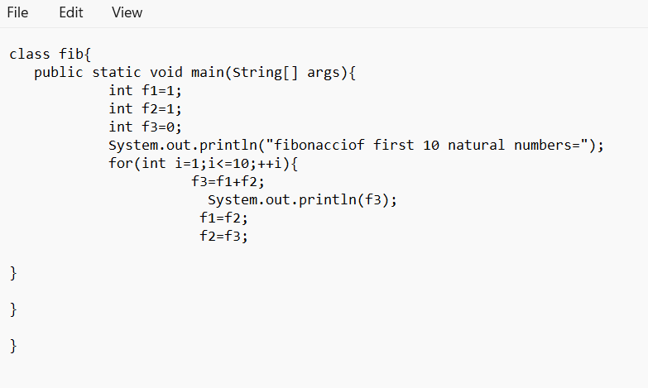

ERROR:

Add semicoloum after f3=f1+f2

Step4: Now save the java file and open the command window and type javac fib.java and compile it.

Step5:Now, the java program is correctly excecuted and there are no errors in the java program.

Program5: Write java program that prints fibinocci of number.

Aim: java program that convert Temperature from celcius to Fahrenheit

Step1: create new notepad folder and write the code of java program that convert Temperature from celcius to Fahrenheit

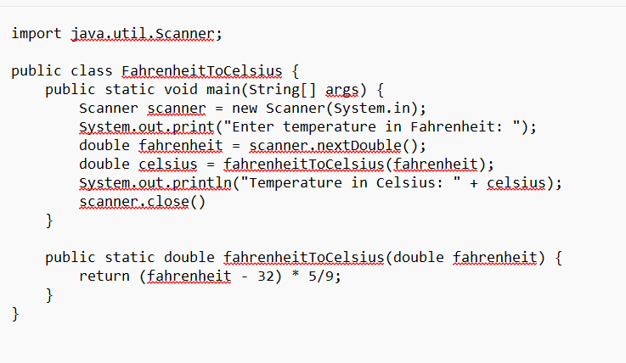

Step2:Save the file as temp.java and open the notepad file in command prompt and compile it.

Step3: So we are getting 1errors which is in the scanner close. Go to notepad and correct the mistake in the statement.

ERROR:

Add semicoloum after scanner close.

Step4: Now save the java file and open the command window and type javac temp.java and compile it.

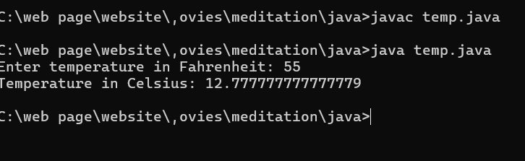Step5:Now, the java program is correctly excecuted and there are no errors in the java program.

Program5: Write java program that prints simple intrest of number by user.

Aim: java program that that prints simple intrest of number by user.

Step1: create new notepad folder and write the code of java program that prints simple intrest of number by user.

Step2:Save the file as simple.java and open the notepad file in command prompt and compile it.

Step3: So we are getting 1errors which is in the float. Go to notepad and correct the mistake in the statement.

ERROR:

Add semicoloum after Float SI;

Step4: Now save the java file and open the command window and type javac simple.java and compile it.

Step5:Now, the java program is correctly excecuted and there are no errors in the java program.

WEEK-3:

Aim: **To create java program with following instructions**

**1.Create a class with name car**

**2. Create four attributes named car_color Car_brand,fuel_type,mileage**

**3. Create three methods named start(), stop(). Service()**

**4. Create three objects named car1,car2 and car3**

Step1: create new notepad folder and write the code of java program that prints class with name car,attributes and three methods with three objects.

import java.util.*;

class car

{

public String Car_color

public String Car_brand;

public String fuel_type;

public int mileage;

public void start()

{

System.out.println("Car Started:");

System.out.println("Car color is :"+Car_color);

System.out.println("Car Brand is:"+Car_brand);

System.out.println("Car fuel type is:"+fuel_type);

System.out.println("Car mileage is:"+mileage);

}

public void service()

{

System.out.println("Car Started:");

System.out.println("Car color is :"+Car_color);

System.out.println("Car Brand is:"+Car_brand);

System.out.println("Car fuel type is:"+fuel_type);

System.out.println("Car mileage is:"+mileage);

}

public void stop()

public static void main(String args[])

{ System.out.println("\nNIKHIL\n\n");

car car1 = new car();

car1.Car_color = "Blue";

car1.Car_brand = "Audi";

car1.fuel_type = "Deisel";

car1.mileage = 100;

car1.start();

car car2 = new car();

car2.Car_color = "Red";

car2.Car_brand = "Tesla";

car2.fuel_type = "EV";

car2.mileage = 200;

car2.stop();

car car3 = new car();

car3.Car_color = "Yellow";

car3.Car_brand = "BMW";

car3.fuel_type = "Petrol";

car3.mileage = 300;

car3.service();

}

}

Step2:Save the file as car.java and open the notepad file in command prompt and compile it.

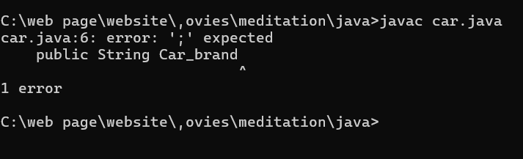

Step3: So we are getting 1errors which is in the string Car_brand. Go to notepad and correct the mistake in the statement.

ERROR:

|  |  |  |  |
| --- | --- | --- | --- |
| **S No** | **Error Type** | **Cause of error** | **Rectification** |
| **1** | **Syntax Error** | **Missing ‘;‘** | **‘;‘ added** |

Step4: Now save the java file and open the command window and type javac car.java and compile it.

Step5:Now, the java program is correctly excecuted and there are no errors in the java program.

Program5:

Aim: java program **To create a class bankAccount with methods deposit() and withdrawl**

**Code:**

Step1: create new notepad folder and write to create banlk account with method to deposoit and withdrawl.

Step2:Save the file as Main1.java and open the notepad file in command prompt and compile it.

Step3: So we are getting 1errors which is in the main string. Go to notepad and correct the mistake in the statement.

ERROR:

|  |  |  |  |
| --- | --- | --- | --- |
| **S.No** | **Error type** | **Reason for error** | **Rectification** |
| **1** | **Logical error** | **Incorrect symbol :** | **Formula rectified** |

Step4: Now save the java file and open the command window and type javac Main1.java and compile it.

Step5:Now, the java program is correctly excecuted and there are no errors in the java program.

WEEK_4

1)AIM: WRITE A JAVA PROGRAM WITH CLASS NAMED “Book”. THE CLASS SHOULD CONTAIN VARIOUS ATTRIBUTES SUCH AS TITLE, AUTHOR, YEAR OF PUBLICATION. IT SHOULD ALSO CONTAIN A CONSTRUCTOR WITH PARAMETERS WHICH INITIALIZES TITLE, AUTHOR, YEAR OF PUBLICATION AND CREATE A METHOD WHICH DISPLAYS THE DETAILS OF 2 BOOKS.

PROGRAM:

class book

{

public String Title;

public String Author;

public int YearofPublication;

book(String Title, String Author,int YearofPublication)

{

this.Title=Title;

this.Author=Author;

this.YearofPublication= YearofPublication;

}

public void Details()

{

System.out.println("Title of the book:"+Title);

System.out.println("Author of the book:"+Author);

System.out.println("Year of Publication of the book:"+YearofPublication);

}

public static void main(String args[])

{

book b1=new book("JAVA Programming Language", "Dr.Suresh",2020);

b1.Details() ;

book b2=new book("Physics", "Dr.Sujata",2009);

b2.Details();

}

}

OUTPUT:

**NEGATIVE CASE:**

**ERROR TABLE:**

|  |  |  |  |
| --- | --- | --- | --- |
| **S.No** | **ERROR TYPE** | **Reason for error** | **Rectification** |
| **1.** | Syntax error | No semicolon | Semicolon added |
| **2.** | Runtime error | Incorrect path | Copied correct path |

**CLASS DIAGRAM:**

|  |
| --- |
| Book |
| -title: String  -author: String  -year: int |
| + Book(title: String, author:String, year: int) + displayDetails(): void |

**2)AIM: WRITE A JAVA PROGRAM WITH CLASS NAMED “MyClass” WITH A STATIC VARIABLE COUNT OF INT TYPE. INTIALIZE IT TO ZERO AND A CONSTANT VARIABLE “Pi” OF TYPE DOUBLE INITIALIZED TO “3.14” AS ATTRIBUTES OF THAT CLASS. NOW DEFINE A CONSTRUCTOR FOR “MyClass”, THAT INCREMENTS THE COUNT VARIABLE EACH TIME AN OBJECT OF “MyClass” IS CREATED. FINALLY, PRINT THE FINAL VALUES OF ‘COUNT’ AND ‘PI’ VARIABLES AND CREATE 3 OBJECTS.**

**OUTPUT:**

**Negative case:**

**Errors:**

|  |  |  |  |
| --- | --- | --- | --- |
| **S.No** | **Error Type** | **Reason for error** | **Rectification** |
| **1.** | **No class** | **No class name declared** | **Created class named ‘MyClass’** |
| **2.** | **Syntax error** | **Not added keyword** | **Added keyword named ‘new’** |

**CLASS DIAGRAM:**

|  |
| --- |
| **MyClass** |
| **-count: int (static)**  **-pi: double (static, final)** |
| **+MyClass()**  **+main(args: String[]):void** |

**WEEK_5:  
AIM: Create a calculator using the operations including addition, subtraction**

**Multiplication and division using multilevel inheritance and display the desired**

**Output**

**Class Diagram:**

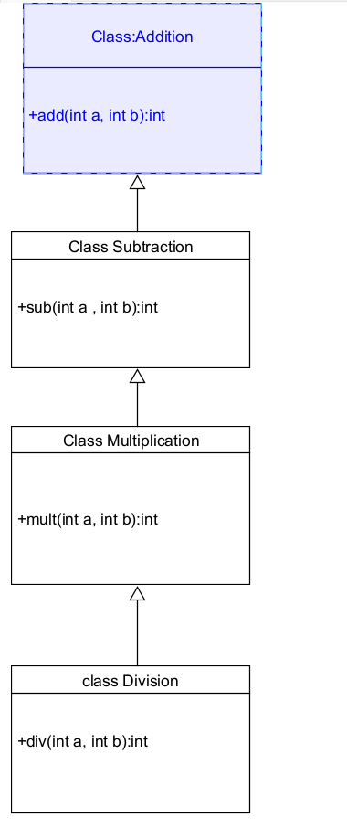

**Code:**

**class addition**

**{**

**public int add(int a, int b)**

**{**

**int addition = a+b;**

**return addition;**

**}**

**}**

**class subtraction extends addition**

**{**

**public int sub(int a, int b)**

**{**

**int subtraction = a-b;**

**return subtraction;**

**}**

**}**

**class multiplication extends subtraction**

**{**

**public int mult(int a, int b)**

**{**

**int multiplication = a*b;**

**return multiplication;**

**}**

**}**

**class division extends multiplication**

**{**

**public int div(int a,int b)**

**{**

**int division = a/b;**

**return division;**

**}**

**}**

**class calculator**

**{**

**public static void main(String args[])**

**{**

**division obj = new division();**

**System.out.println("Addition is:"+ obj.add(10,2));**

**System.out.println ("Subtraction is:"+obj.sub(8,4));**

**System.out.println("Multiplication is:"+obj.mult(12,4));**

**System.out.println("Division is:"+obj.div(8,4));**

**}**

**}**

**Output**

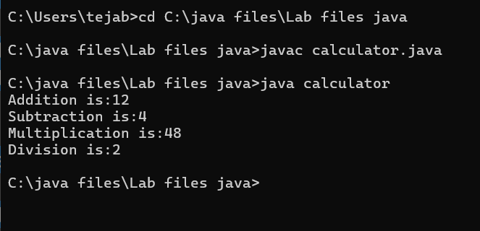

**Error Table**

|  |  |  |  |
| --- | --- | --- | --- |
| **S.No** | **Error Type** | **Cause** | **Rectification** |
| **1** | **Constructor error** | **Invalid name to method** | **Defined class name** |
| **2** | **Syntax error** | **Expected ‘(‘** | **Added parenthesis** |
| **3** | **Logical error** | **Incorrect arithmetic**  **operation** | **Correct operation**  **rectified** |

**Negative Case:**

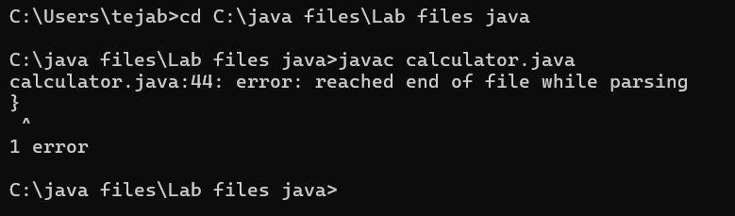

**Important Points**

**Inheritence:**

**The concept of OOP where a class inherits the properties and behaviours from**

**Another class (parent class) which promotes code reusability and hieratchical relationships**

**Multilevel Inheritence:**

**This is a type of inheritance in which a class inherited from another class, and**

**That superclass, in turn, inherits from yet another class, creating a chain of**

**inheritence**

**extends:**

**The extends keyword defines the relation of child class with the parent class**

**2.**

**Aim: A vehicle rental company wants to develop a system that maintains**

**Information about different types of vehicles available for rent**

**The Company rents out cars, bikes and truck and they need a program to**

**Store details about each vehicle, such as brand and speed**

**Cars should have an additional property: number of doors**

**Bikes should have a property indicating whether they have gears or not**

**The system should also include a function to display details about each vehicle**

**And indicate when a vehicle is starting**

**Class diagram**

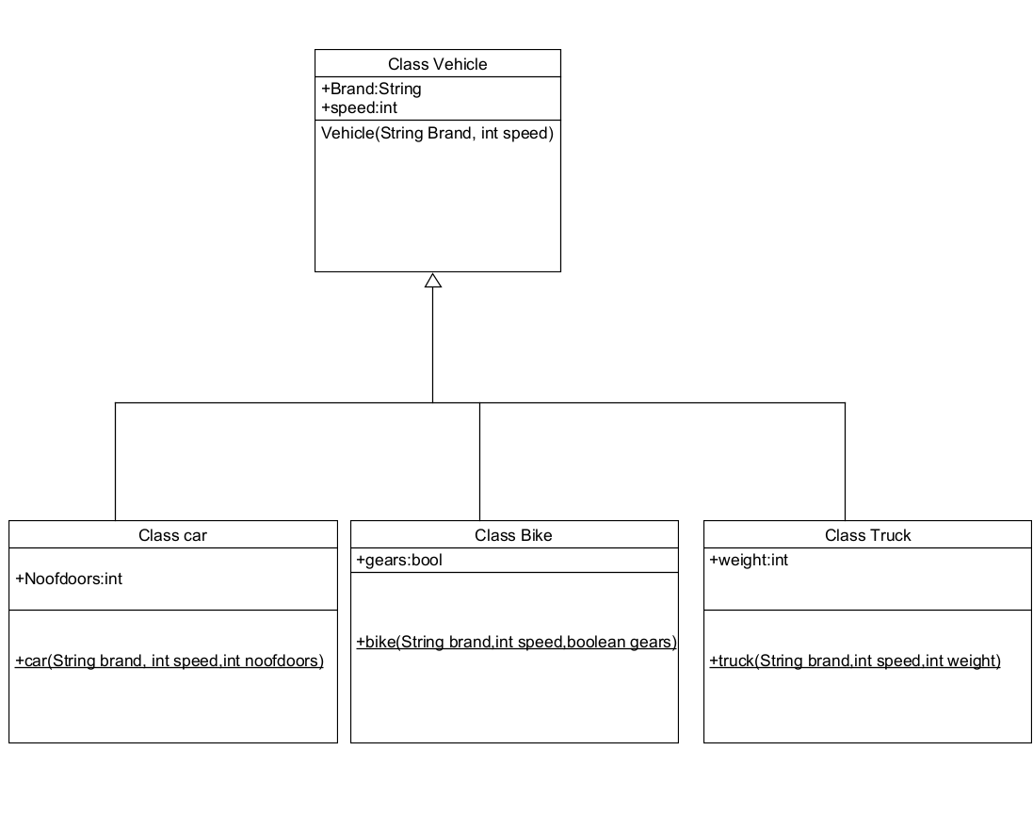

**Code:**

**class vehicle{**

**String brand;**

**int speed;**

**public vehicle(String brand,int speed){**

**this.brand=brand;**

**this.speed=speed;**

**}**

**public static void main(String[] args) {**

**car obj1=new car("ford",34,4);**

**bike obj2=new bike("hero",100,true);**

**truck obj3=new truck("tata",60,40);**

**}**

**}**

**class car extends vehicle{**

**int noofdoors;**

**public car(String brand, int speed,int noofdoors) {**

**super(brand, speed);**

**this.noofdoors=noofdoors;**

**System.out.println("Brand of car is:"+brand);**

**System.out.println("Speed of car is:"+speed);**

**System.out.println("no of doors of car:"+noofdoors);**

**}**

**}**

**class bike extends vehicle{**

**boolean gears;**

**public bike(String brand,int speed,boolean gears){**

**super(brand, speed);**

**this.gears=gears;**

**System.out.println("Brand of bike is:"+brand);**

**System.out.println("Speed of bike is:"+speed);**

**System.out.println("Gears of bike:"+gears);**

**}**

**}**

**class truck extends vehicle{**

**int weight;**

**public truck(String brand,int speed,int weight){**

**super(brand,speed);**

**this.weight=weight;**

**System.out.println("Brand name is:"+brand);**

**System.out.println("Speed of Truck is:"+speed);**

**System.out.println("Weight of load is"+weight);**

**}**

**}**

**Output:**

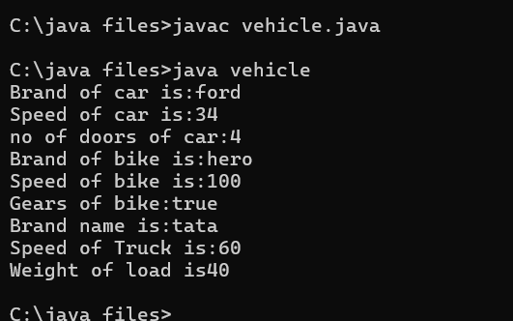

**Error Table:**

|  |  |  |  |
| --- | --- | --- | --- |
| **S No** | **Error Type** | **Cause** | **Rectification** |
| **1** | **Syntax Error** | **Semicolon missing** | **Added ;** |
| **2** |  |  |  |
| **3** |  |  |  |

**Negative Case:**

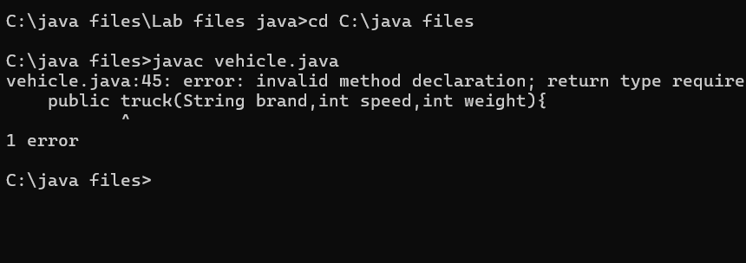

**Important Points**

**Hierarchical Inheritence:**

**This is a type of inheritance occurs when multiple subclasses inherit from a Single parent class.**

**WEEK-6**

**1)Write a java program to create a vechiles class with a method displayinfo() override this method in the car subclass to provide specific information about a car**

* **Company**
* **Model**
* **Price**
* **Seating capacity**
* **Petrol or not**

**Program:**

**class Vehicle {**

**String Brand;**

**String model;**

**String fuel;**

**String color;**

**int capacity;**

**Vehicle(String Brand, String model, String fuel, int capacity, String color) {**

**this.Brand = Brand;**

**this.model = model;**

**this.fuel = fuel;**

**this.capacity = capacity;**

**this.color = color;**

**}**

**void displayInfo(String Brand, String model, String fuel, int capacity, String color) {**

**System.out.println("Vehicle Details: ");**

**System.out.println("Brand: " + Brand);**

**System.out.println("Model: " + model);**

**System.out.println("Fuel: " + fuel);**

**System.out.println("Capacity: " + capacity);**

**System.out.println("Color: " + color);**

**}**

**}**

**class Car extends Vehicle {**

**Car(String Brand, String model, String fuel, int capacity, String color) {**

**super(Brand, model, fuel, capacity, color);**

**}**

**void displayInfo() {**

**System.out.println("B.Tirumala Sai");**

**System.out.println("CSE-A");**

**System.out.println("Roll.NO:24028");**

**System.out.println("");**

**System.out.println("Car Details: ");**

**System.out.println("Brand: " + Brand);**

**System.out.println("Model: " + model);**

**System.out.println("Fuel: " + fuel);**

**System.out.println("Capacity: " + capacity);**

**System.out.println("Color: " + color);**

**}**

**}**

**class Week6_1 {**

**public static void main(String[] args) {**

**// Creating an instance of Car**

**Car car1 = new Car("toyata", "fortuner", "Petrol", 6, "Red");**

**car1.displayInfo();**

**}**

**}**

**Output:**

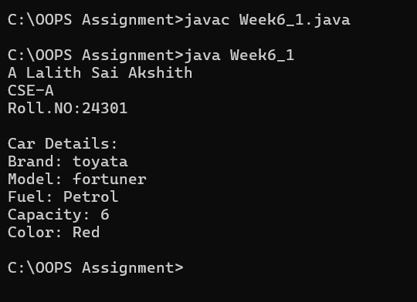

**CLASS DIAGRAM:**

|  |
| --- |
| **Vehicle** |
| **+display info():void** |

|  |
| --- |
| **Car** |
| **+displayinfo():void** |

**ERROR:**

|  |  |  |
| --- | --- | --- |
| **s.no** | **Expected error** | **reason** |
| **1.** | **Settingtheparametersinside the constructor** | **Wecannotpassthe valuesinsideconstructor without setting them first** |
| **2.** | **}** | **Ending the class and main method is required** |

**2Q) A college is developing automated admission system that verifies students eligibility for UG and PG programs .Each program has different eligibility criteria based on the students percentage in their previous qualification.**

* **UG admission require minimum 60%**
* **PG admission require minimum 70%**

**Program:**

**import java.util.Scanner;**

**class College {**

**String name;**

**int qualification;**

**int percentage;**

**College(String name, int qualification, int percentage) {**

**this.name = name;**

**this.qualification = qualification;**

**this.percentage = percentage;**

**}**

**public void Eligibility() {**

**System.out.println("Name: " + name + ", Qualification: " + qualification + ", Percentage: " + percentage);**

**System.out.println("The candidate is a fluke");**

**}**

**}**

**class UG extends College {**

**UG(String name, int qualification, int percentage) {**

**super(name, qualification, percentage);**

**}**

**public void Eligibility() {**

**System.out.println("Name: " + name + ", Qualification: " + qualification + ", Percentage: " + percentage);**

**System.out.println("The candidate is eligible for UG");**

**}**

**}**

**class PG extends College {**

**PG(String name, int qualification, int percentage) {**

**super(name, qualification, percentage);**

**}**

**public void Eligibility() {**

**System.out.println("Name: " + name + ", Qualification: " + qualification + ", Percentage: " + percentage);**

**System.out.println("The candidate is eligible for PG");**

**}**

**}**

**public class Main {**

**public static void main(String[] args) {**

**Scanner input = new Scanner(System.in);**

**System.out.println("Enter your name:");**

**String name = input.nextLine();**

**System.out.println("Enter your qualification (e.g., 12 for high school, 10 for 10th, etc.):");**

**int qualification = input.nextInt();**

**System.out.println("Enter your percentage:");**

**int percentage = input.nextInt();**

**input.close();**

**College candidate;**

**if (percentage >= 70) {**

**candidate = new PG(name, qualification, percentage);**

**} else if (percentage >= 60) {**

**candidate = new UG(name, qualification, percentage);**

**} else {**

**candidate = new College(name, qualification, percentage);**

**}**

**candidate.Eligibility();**

**}**

**}**

**Input:**

* **Name:A Lalith Sai Akshith**
* **Qualification: 12**
* **Percentage:96 OUTPUT:** 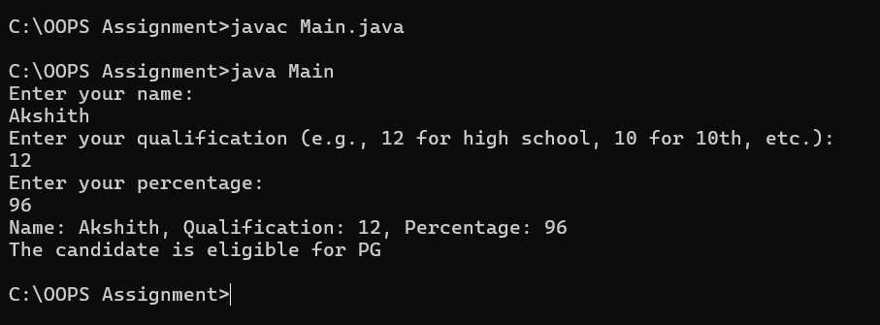

**CLASS DIAGRAM:**

|  |
| --- |
| **adm** |
| **elg():void** |

|  |  |
| --- | --- |
| **ug** | **pg** |
| **+elg():void** | **+elg():void** |
|  |  |

**ERROR:**

|  |  |  |
| --- | --- | --- |
|  | **Expected Error** | **Reason** |
| **1** | **Setting the parameters inside the constructor** | **We cannot pass the values inside constructor without setting them first** |
| **2** | **}** | **Ending the class and main method is required** |

**3Q)Create a calculator class with overloading methods to perform addition**

* **Add two doubles**
* **Add two integer**
* **Add three integer**

**Program:**

**public class Calculator{**

**public int add(int a, int b) {**

**return a + b;**

**}**

**public int add(int[] tuple1, int[] tuple2) {**

**int sum = 0;**

**for (int i = 0; i < tuple1.length; i++) {**

**sum += tuple1[i] + tuple2[i];**

**}**

**return sum;**

**}**

**public int add(int a, int b, int c) {**

**return a + b + c;**

**}**

**public static void main(String[] args) {**

**Calculator calc = new Calculator();**

**int result1 = calc.add(10, 20);**

**System.out.println("Addition of two integers: " + result1);**

**int[] tuple1 = {1, 2};**

**int[] tuple2 = {3, 4};**

**int result2 = calc.add(tuple1, tuple2);**

**System.out.println("Addition of two tuples: " + result2);**

**int result3 = calc.add(5, 10, 15);**

**System.out.println("Addition of three integers: " + result3);**

**}**

**}**

**OUTPUT:**

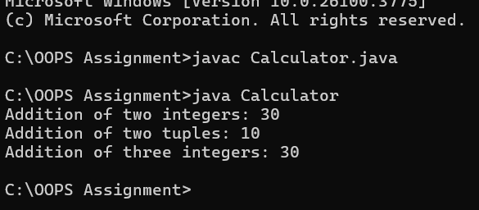

**CLASS DIAGRAM:**

|  |
| --- |
| **cacluator** |
| **+add(int a,int b):int**  **+add(double a,double b):double**  **+add(int a,int b,int c):int** |

**ERROR:**

|  |  |  |
| --- | --- | --- |
| **S.No.** | **Expected Error** | **Reason** |
| **1** | **Setting the parameters inside the constructor** | **We cannot pass the values inside constructor without setting them first** |
| **2** | **}** | **Ending the class and main method is required** |

**4.Create a shape class with method calculateArea() that is overloaded for different shapes (eg: square, rectangle).Then create a subclass Circle that overrides calculateArea() method for Circle.**

**CODE:**

**class shape{**

**public float calarea(float side){ return side*side;**

**}**

**public float calarea(float l,float b){ return l*b;**

**}**

**}**

**class circle extends shape{**

**public double calarea(double r){ return 3.14*r*r;**

**}**

**}**

**class s{**

**public static void main(String[] args){ circle c=new circle(); System.out.println(c.calarea(10));**

**}**

**}**

**OUTPUT:**

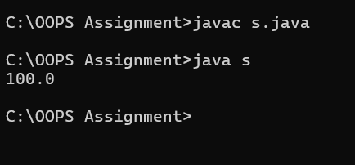

**CLASS DIAGRAM:**

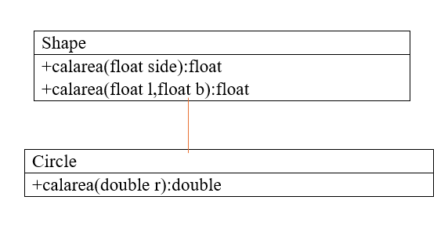**ERRORS:**

|  |  |  |
| --- | --- | --- |
| **s.no** | **Expected error** | **reason** |
| **1.** | **Setting the parameters inside the constructor** | **We cannot pass the values inside constructor without setting them first** |
| **2.** | **}** | **Ending the class and main method is required** |

**WEEK-7**

**1Q)Write a java program to create an abstract class Animal with an abstract method sound().Create Subclass Tiger and Lion extends the Animal class and implement the sound() method to make a specific sound for each animal**

**Program:**

**abstract class Animal {**

**public abstract void sound();**

**}**

**class Lion extends Animal {**

**@Override**

**public void sound() {**

**System.out.println("Lion: Roar!");**

**}**

**}**

**class Tiger extends Animal {**

**@Override**

**public void sound() {**

**System.out.println("Tiger: Growl!");**

**}**

**}**

**public class Q1labw7 {**

**public static void main(String[] args) {**

**Animal lion = new Lion();**

**Animal tiger = new Tiger();**

**lion.sound();**

**tiger.sound();**

**}**

**}**

**OUTPUT:**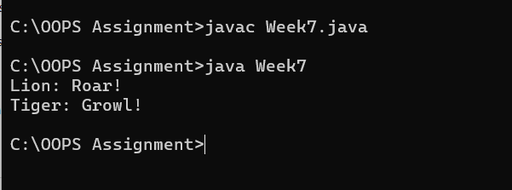

**Error Table:**

|  |  |  |
| --- | --- | --- |
| **S.no** | **Expected Error** | **Reason** |
| **1** | **Setting the parameters inside the constructor** | **We cannot pass the values inside constructor without setting them first** |
| **2** | **}** | **Ending the class and main method is required** |

**Class Diagram:**

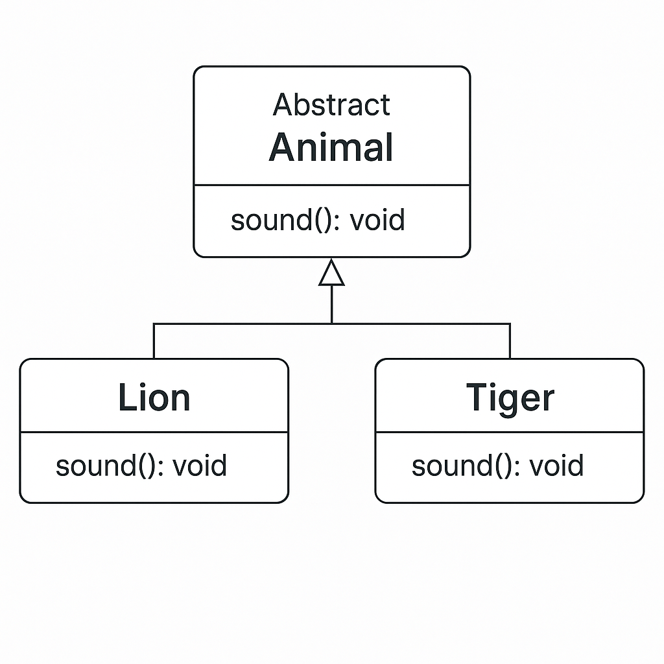

**2Q)Write a java program to create an abstract class Shape3D with an abstract methods Calculate_volume() and Calculate_Surface_area.Create Subclass Sphere and Cube extends the Shape3D class and implement the respective methods to calculate the volume and surface_area of each shape.**

**Program:**

**abstract class Shape3D {**

**public abstract void calculate_volume();**

**public abstract void calculate_surf_a();**

**}**

**class Sphere extends Shape3D {**

**private double radius;**

**public Sphere(double radius) {**

**this.radius = radius;**

**}**

**@Override**

**public void calculate_surf_a() {**

**double surfaceArea = 4 * Math.PI * Math.pow(radius, 2);**

**System.out.printf("Surface Area of Sphere: %.2f%n", surfaceArea);**

**}**

**@Override**

**public void calculate_volume() {**

**double volume = (4.0 / 3) * Math.PI * Math.pow(radius, 3);**

**System.out.printf("Volume of Sphere: %.2f%n", volume);**

**}**

**}**

**class Cube extends Shape3D {**

**private double side;**

**public Cube(double side) {**

**this.side = side;**

**}**

**@Override**

**public void calculate_surf_a() {**

**double surfaceArea = 6 * Math.pow(side, 2);**

**System.out.printf("Surface Area of Cube: %.2f%n", surfaceArea);**

**}**

**@Override**

**public void calculate_volume() {**

**double volume = Math.pow(side, 3);**

**System.out.printf("Volume of Cube: %.2f%n", volume);**

**}**

**}**

**public class Q2labw7 {**

**public static void main(String[] args) {**

**Shape3D sphere = new Sphere(5);**

**Shape3D cube = new Cube(3);**

**sphere.calculate_surf_a();**

**sphere.calculate_volume();**

**cube.calculate_surf_a();**

**cube.calculate_volume();**

**}**

**}**

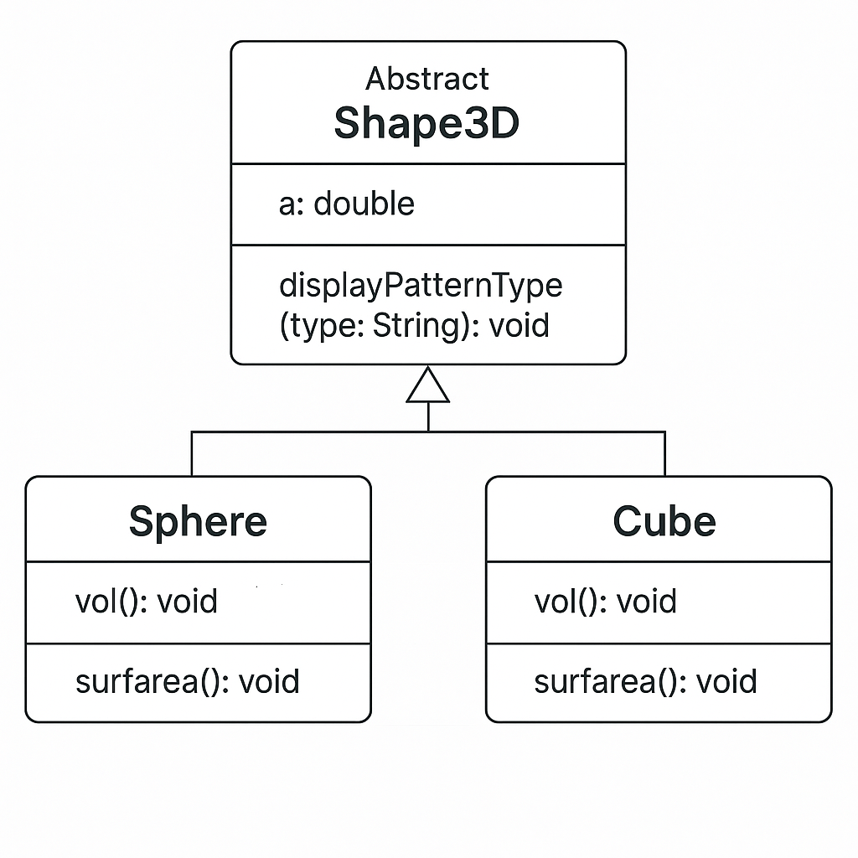

**Output:** 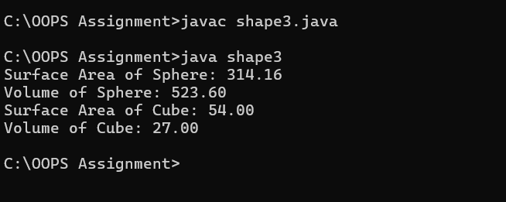

**Error Table:**

|  |  |  |
| --- | --- | --- |
| **S.no** | **Expected Error** | **Reason** |
| **1** | **Setting the parameters inside the constructor** | **We cannot pass the values inside constructor without setting them first** |
| **2** | **}** | **Ending the class and main method is required** |

**Error Table:**

|  |  |  |
| --- | --- | --- |
| **S.no** | **Expected Error** | **Reason** |
| **1** | **Setting the parameters inside the constructor** | **We cannot pass the values inside constructor without setting them first** |
| **2** | **}** | **Ending the class and main method is required** |

**Error Table:**

|  |  |  |
| --- | --- | --- |
| **S.no** | **Expected Error** | **Reason** |
| **1** | **Setting the parameters inside the constructor** | **We cannot pass the values inside constructor without setting them first** |
| **2** | **}** | **Ending the class and main method is required** |

**3Q)Write a java program using an abstract class to define a method for pattern printing**

**-->create an abstract class named patternprinting with an abstract method print pattern (int n) and a concrete method to display the pattern title**

**-->impletment two sub classes**

**1)star pattern**

**Prints a right angled triangle of stars**

**2)Number pattern**

**Prints a right angled triangle of increasing numbers**

**-->in the main()method create objects of both sub classes and print the patterns for a given number of rows**

**Program:**

**import java.util.Scanner;**

**abstract class Pattern {**

**public abstract void printPattern(int n);**

**}**

**class RightTrianglePattern extends Pattern {**

**@Override**

**public void printPattern(int n) {**

**System.out.println("Right Triangle Pattern:");**

**for (int i = 1; i <= n; i++) {**

**for (int j = 1; j <= i; j++) {**

**System.out.print("* ");**

**}**

**System.out.println();**

**}**

**}**

**}**

**class NumberPattern extends Pattern {**

**@Override**

**public void printPattern(int n) {**

**System.out.println("number pattern:");**

**for (int i =1; i <= n; i++) {**

**for (int j = 1; j <= i; j++) {**

**System.out.print( j);**

**}**

**System.out.println();**

**}**

**}**

**}**

**public class Q3labw7 {**

**public static void main(String[] args) {**

**Scanner input= new Scanner(System.in);**

**System.out.println("enter the n value to select number of rows");**

**int n=input.nextInt();**

**Pattern rightTriangle = new RightTrianglePattern();**

**Pattern numberpattern = new NumberPattern();**

**rightTriangle.printPattern(n);**

**numberpattern.printPattern(n);**

**}**

**}**

OUTPUT: 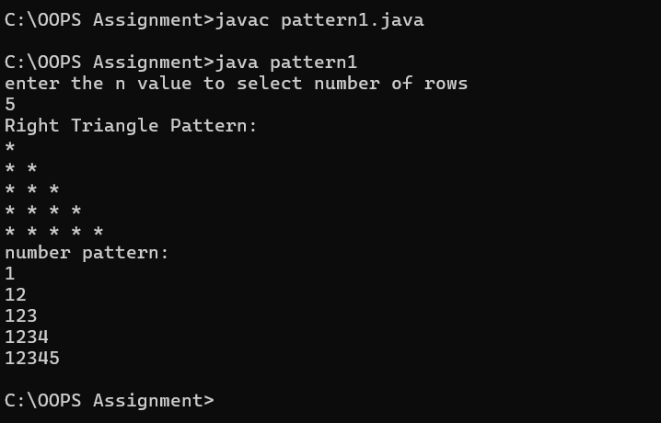

Class diagram:

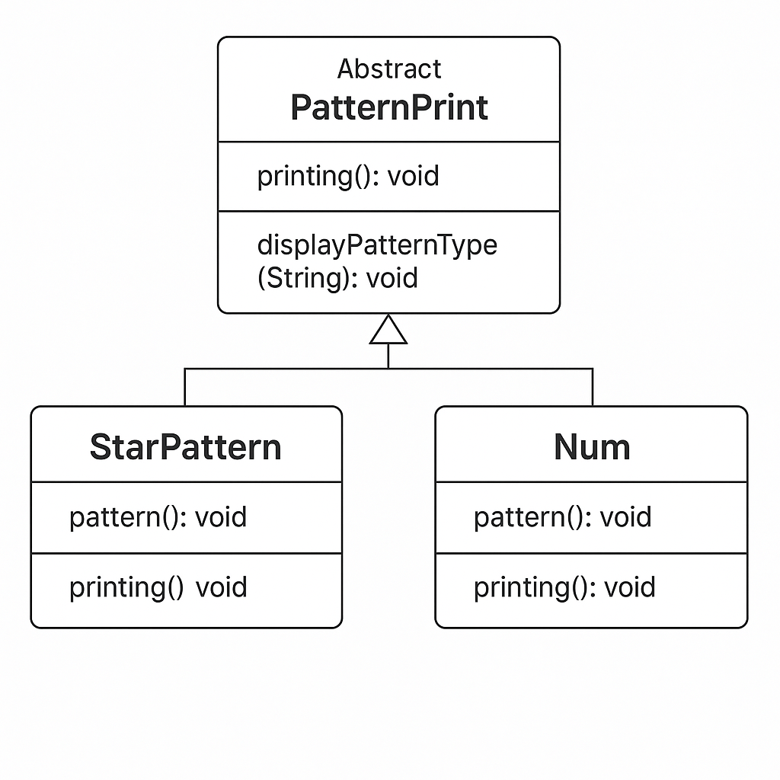

**Error Table:**

|  |  |  |
| --- | --- | --- |
| S.no | Expected Error | Reason |
| **1** | Setting the parameters inside the constructor | We cannot pass the values inside constructor without setting them first |
| **2** | } | Ending the class and main method is required |